**DESIGN PATTERNS**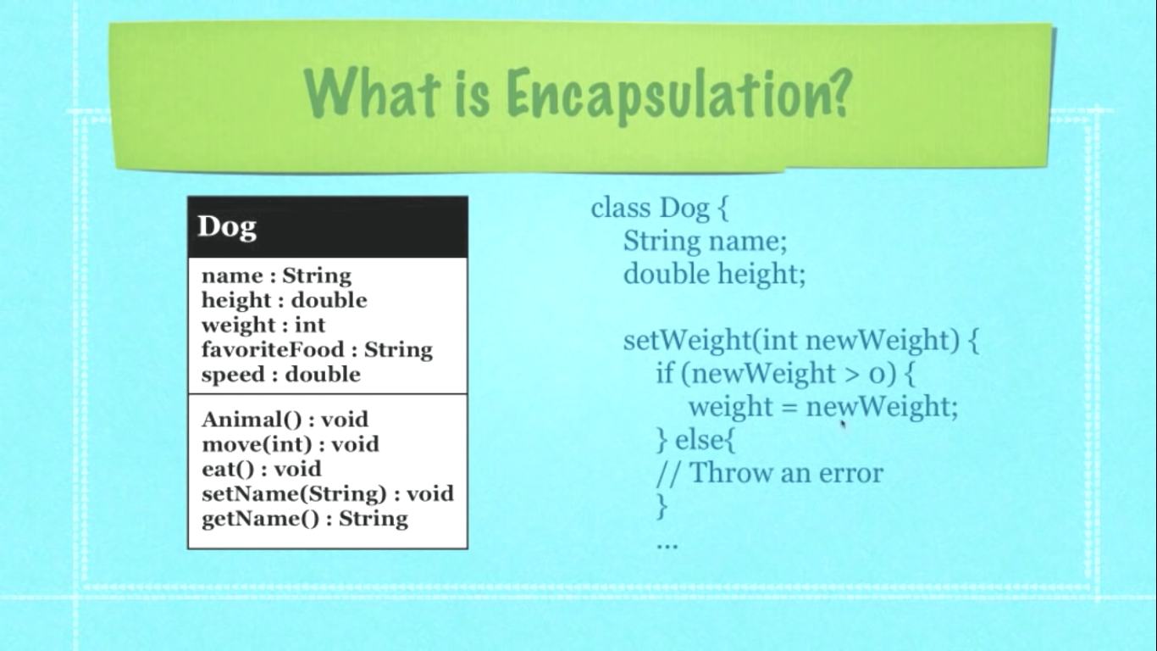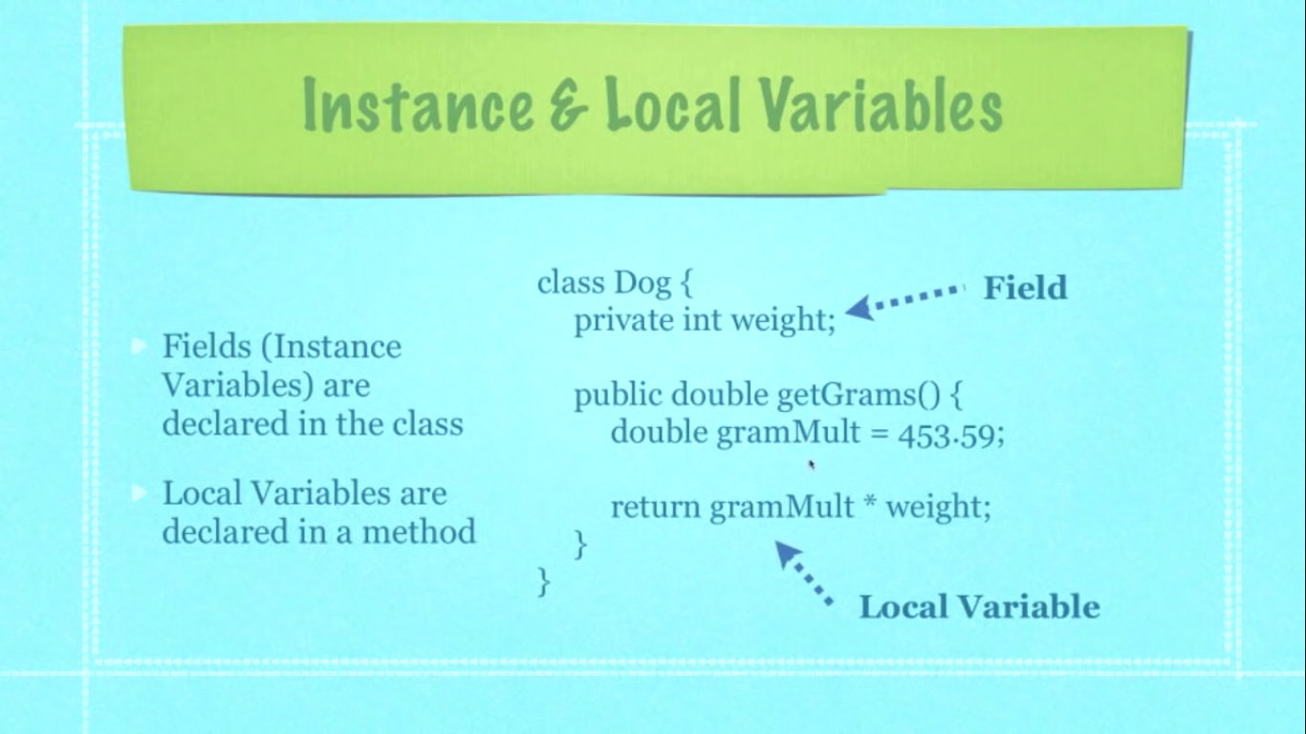 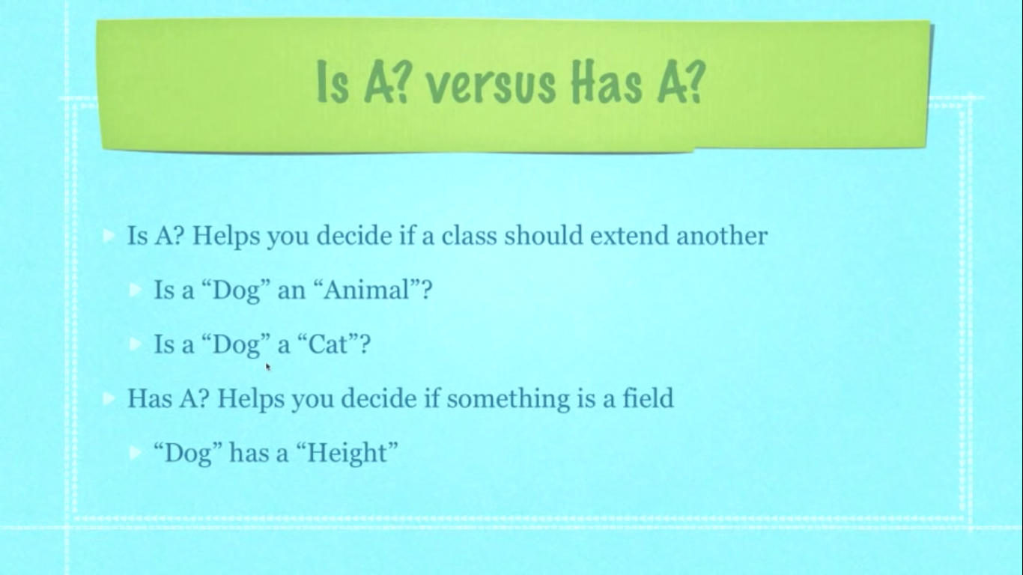  



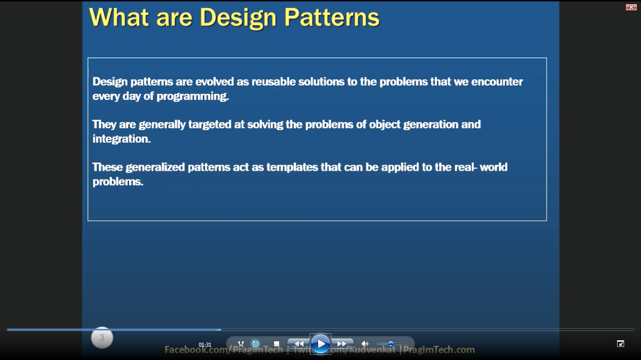

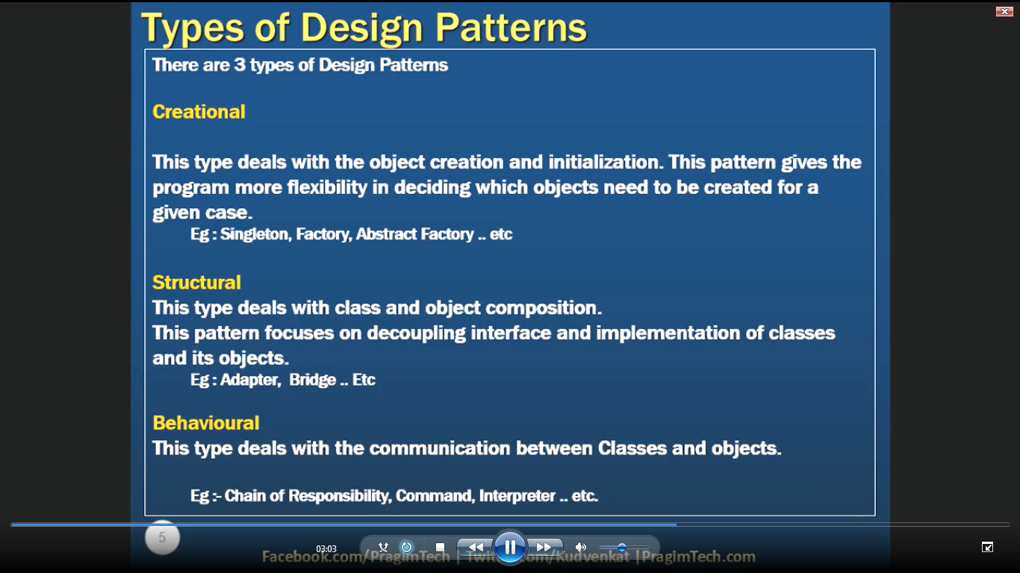



**In C# Singleton.**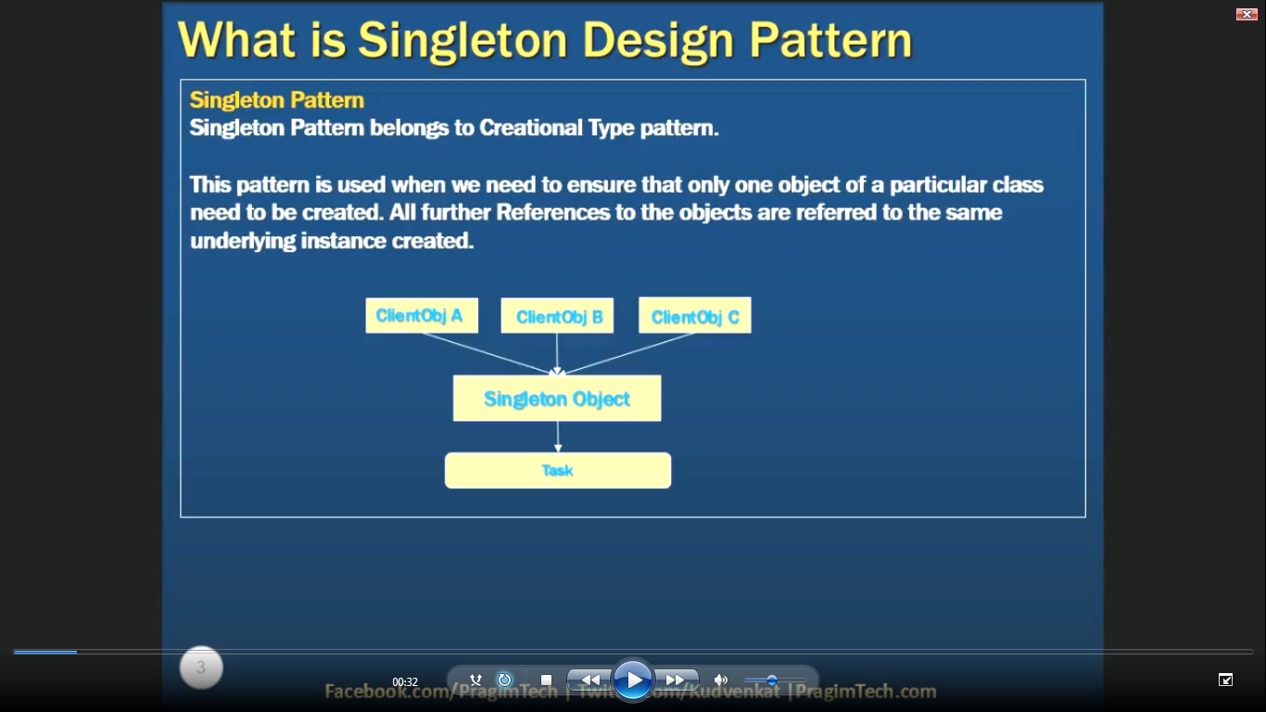



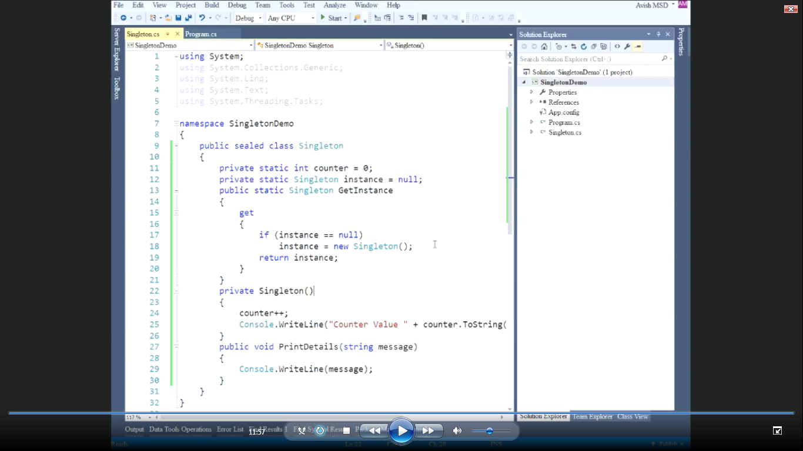  
Why do we use design patterns?

In software engineering, a software **design pattern** is a general reusable solution to a commonly occurring problem within a given context in software **design**. ... **Design patterns** are formalized best practices that the programmer can use to solve common problems when **designing** an application or system.

What is the Singleton pattern?

In software engineering, the **singleton pattern** is a software design **pattern** that restricts the instantiation of a class to one object. ... The concept is sometimes generalized to systems that operate more efficiently when only one object exists, or that restrict the instantiation to a certain number of objects.

**Singleton Class is used for increase efficiently program because when we create a singleton class and program will only one time create an object and call only one time and programmer want to create many times of objects.  
  
Design Pattern is use for our software and system because it is a reusable common problem solution whose occur our software and system. And awesome application design without any bug.**

**Sealed singleton class or just a sealed class will not to inherit for derived externally or nested into the class   
  
private constructor help preventing to externally instantiating of an object.**

**Strategy Patterns  
When you need to use one of several behaviors dynamically  
Like two animal one is dog and another is bird but one behavior is fly and condition is dog is not fly and bird is fly.**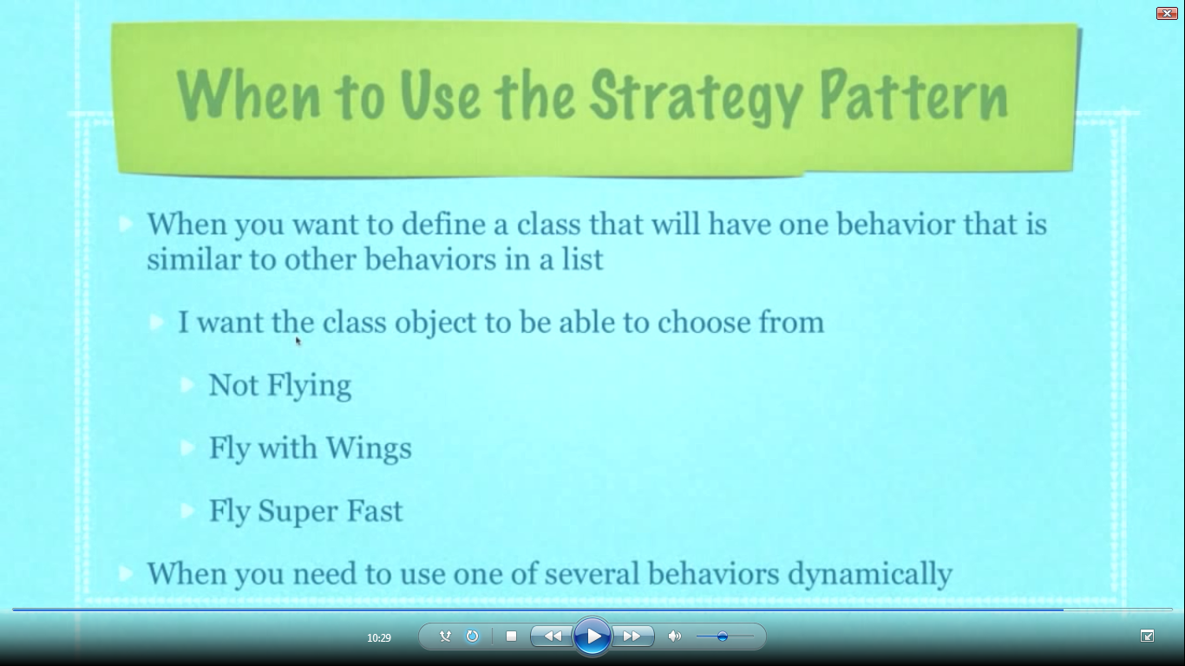

**Define a family of algorithms, encapsulate each one, and make them interchangeable, The** STRAGETY PETTERN **lets the algorithm vary independently from clients that use it.**